## Reports/ Rx Reports/ Override Report

Request:

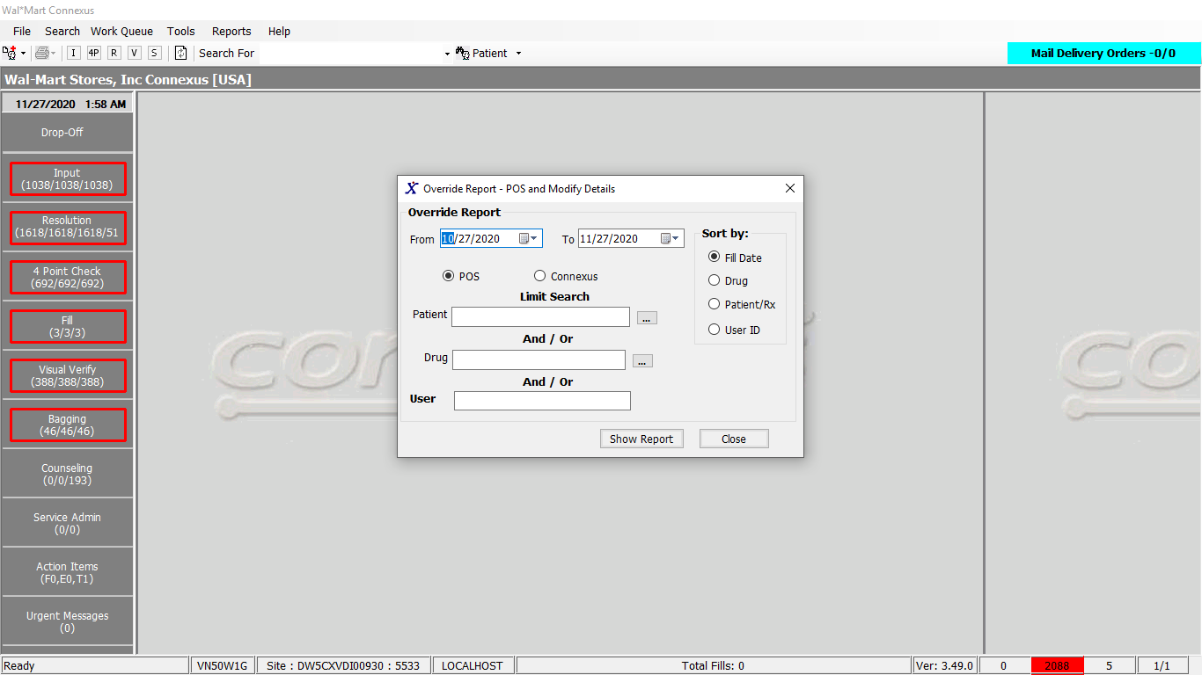

Response:

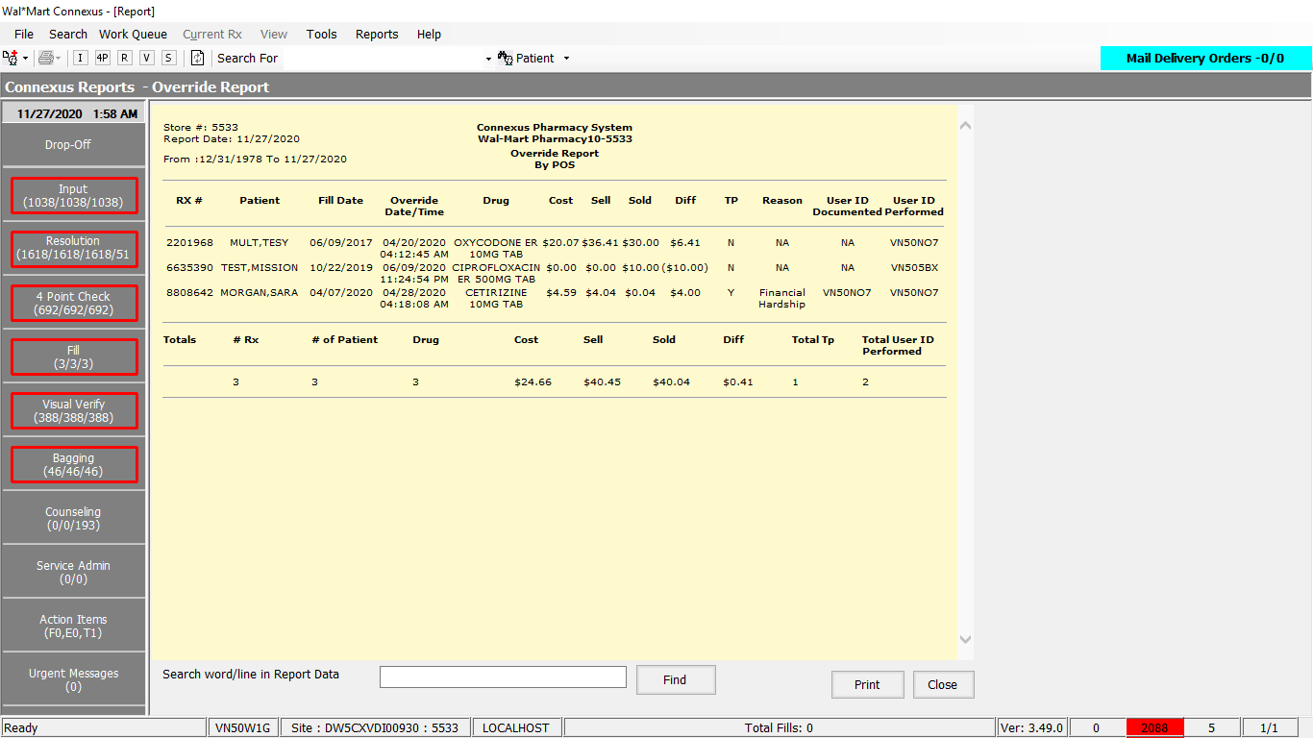

Queries:

1.Friend Const GetOverrideReportDataSelect1 As String = "SELECT rx_nbr, rf.rx_fill_id, TRIM(NVL(pat.last_name,'')) || ',' || TRIM(NVL(pat.first_name,'')) || ' ' || TRIM(NVL(pat.middle_name,'')) pat_name, rf.fill_date, CASE WHEN rx.compound_ind ='Y' THEN c.compound_name WHEN rx.compound_ind !='Y' THEN pp.short_name END drug_name, SUM(rfi2.actual_cost_amt) cost_amt, rf.patient_due_amt sell, pa.pos_patient_amt sold, rf.third_party_ind, pa.pos_operator_id userid, '' comment, rx.rx_id , pa.pos_ts , CASE WHEN rf.third_party_ind = 'Y' THEN (SELECT cc.create_userid FROM comment cc WHERE cc.comment_id =(select max(cl.comment_id) from comment_line cl, comment cc , rx_comment rc where rc.rx_id = rx.rx_id and cc.comment_id = rc.comment_id and cc.comment_id = cl.comment_id and cl.comment_text LIKE '%Price was overidden%')) WHEN rf.third_party_ind != 'Y' THEN 'NA' END create_userid , CASE WHEN rf.third_party_ind = 'Y' THEN (SELECT cl.comment_text FROM comment_line cl WHERE cl.comment_id = (Select MAX(cl.comment_id) from comment_line cl, comment cc , rx_comment rc where cl.comment_text LIKE '%Price was overidden%' and rc.rx_id = rx.rx_id and cc.comment_id = rc.comment_id and cc.comment_id = cl.comment_id)) WHEN rf.third_party_ind != 'Y' THEN 'NA' END comment_text FROM rx, patient pat, rx_fill rf, rx_fill_item rfi, pos_activity pa, rx_fill_item rfi2, pharmacy_offering:pharmacy_product pp, pharmacy_offering:pharmacy_item pi, OUTER (rx_compound rxc, compound c) WHERE rx.rx_id = rf.rx_id AND rx.rx_id = rxc.rx_id AND rxc.compound_id = c.compound_id AND rx.patient_id = pat.patient_id AND rf.rx_fill_id = pa.rx_fill_id AND pa.pos_txn_type_code = 5700 AND pa.pos_seq_nbr = (SELECT MAX(pos_seq_nbr) FROM pos_activity pa2 WHERE pa2.rx_fill_id = pa.rx_fill_id AND pa2.pos_txn_type_code = 5700) AND rf.pos_sale_amt IS NOT NULL AND rf.rx_fill_id = rfi.rx_fill_id AND rfi.item_mds_fam_id = pi.mds_fam_id AND pi.product_mds_fam_id = pp.product_mds_fam_id AND rfi.item_seq_nbr = 1 AND rf.rx_fill_id = rfi2.rx_fill_id AND rf.status_code = 20401 AND rf.fill_date >= ? AND rf.fill_date <= ? AND rf.patient_due_amt <> pa.pos_patient_amt "

2. Friend Const GetOverrideReportDataSelect2 As String = "SELECT rx_nbr, rf.rx_fill_id, TRIM(NVL(pat.last_name,'')) || ',' || TRIM(NVL(pat.first_name,'')) || ' ' || TRIM(NVL(pat.middle_name,'')) pat_name, rf.fill_date, CASE WHEN rx.compound_ind ='Y' THEN c.compound_name WHEN rx.compound_ind !='Y' THEN pp.short_name END drug_name, SUM(rfi2.actual_cost_amt) cost_amt, 0 sell, 0 sold, rf.third_party_ind, com.create_userid userid, cl.comment_text comment, rx.rx_id FROM rx, patient pat, rx_fill rf, rx_fill_comment rfc, comment com, comment_line cl, rx_fill_item rfi, pos_activity pa, rx_fill_item rfi2, pharmacy_offering:pharmacy_product pp, pharmacy_offering:pharmacy_item pi, OUTER (rx_compound rxc, compound c) WHERE rx.rx_id = rf.rx_id AND rx.rx_id = rxc.rx_id AND rxc.compound_id = c.compound_id AND rx.patient_id = pat.patient_id AND rf.rx_fill_id = pa.rx_fill_id AND pa.pos_txn_type_code = 5700 AND pa.pos_seq_nbr = (SELECT MAX(pos_seq_nbr) FROM pos_activity pa2 WHERE pa2.rx_fill_id = pa.rx_fill_id AND pa2.pos_txn_type_code = 5700) AND rf.pos_sale_amt IS NOT NULL AND rf.rx_fill_id = rfi.rx_fill_id AND rfi.item_mds_fam_id = pi.mds_fam_id AND pi.product_mds_fam_id = pp.product_mds_fam_id AND rfi.item_seq_nbr = (SELECT NVL(MIN(rfi3.item_seq_nbr),1) FROM rx_fill_item rfi3 WHERE rfi3.rx_fill_id = rfi.rx_fill_id) AND rf.rx_fill_id = rfi2.rx_fill_id AND rf.status_code = 20401 AND rf.fill_date >= ? AND rf.fill_date <= ? AND rf.rx_fill_id = rfc.rx_fill_id AND rfc.comment_id = com.comment_id AND com.comment_id = cl.comment_id AND com.comment_type_code = 200 AND com.comment_subj_code = 118 "

DAL:

Public Function GetOverrideReportData(ByVal siteId As Integer,

ByVal getOverrideReportDataInputInfo As _

GetOverrideReportDataInputInfoBE) As _

List(Of GetOverrideReportDataInfoBE) Implements IReportDAL.GetOverrideReportData

Using (New Tracer(ConnexusCommonConstants.ConnexusTracer))

Dim sqlString As New StringBuilder

Dim getOverrideReportDataBEList As New List(Of GetOverrideReportDataInfoBE)

Dim orderBy As String = Nothing

Dim paramList As New List(Of DbParameter)

If getOverrideReportDataInputInfo.OrderBy = 1 Then

orderBy = "rf.fill_date"

ElseIf getOverrideReportDataInputInfo.OrderBy = 2 Then

orderBy = "drug_name"

ElseIf getOverrideReportDataInputInfo.OrderBy = 3 Then

orderBy = "pat_name"

ElseIf getOverrideReportDataInputInfo.OrderBy = 4 Then

orderBy = "userid"

End If

If getOverrideReportDataInputInfo.Pos = "POS" Then 'SQL Query for POS

sqlString.Append(ReportQueries.GetOverrideReportDataSelect1)

Else 'SQL Query for Connexus

sqlString.Append(ReportQueries.GetOverrideReportDataSelect2)

End If

paramList.Add(ParameterHelper.BuildParameter("fillDate", DbType.Date,

getOverrideReportDataInputInfo.FromDate))

paramList.Add(ParameterHelper.BuildParameter("fillDate", DbType.Date,

getOverrideReportDataInputInfo.ToDate))

If getOverrideReportDataInputInfo.PatId > 0 Then

sqlString.Append(" AND rx.patient_id = ? ")

paramList.Add(ParameterHelper.BuildParameter("patientId", DbType.Int32,

getOverrideReportDataInputInfo.PatId))

ElseIf getOverrideReportDataInputInfo.ProductId > 0 Then

sqlString.Append(" AND pp.product_mds_fam_id = ? ")

paramList.Add(ParameterHelper.BuildParameter("productMDSFamId", DbType.Int32,

getOverrideReportDataInputInfo.ProductId))

ElseIf Not getOverrideReportDataInputInfo.UserId Is Nothing _

AndAlso (getOverrideReportDataInputInfo.UserId).Length > 1 Then

sqlString.Append(" AND pa.pos_operator_id = ?")

paramList.Add(ParameterHelper.BuildParameter("posOperatorId", DbType.String,

getOverrideReportDataInputInfo.UserId))

End If

If getOverrideReportDataInputInfo.Pos = "POS" Then 'SQL Query for POS

sqlString.Append(" GROUP BY 1,2,3,4,5,7,8,9,10,11,12,13,14,15 ORDER BY ")

Else

sqlString.Append(" GROUP BY 1,2,3,4,5,7,8,9,10,11,12 ORDER BY ")

End If

sqlString.Append(orderBy)

Dim dataReader As IDataReader = ExecuteReader(DatabaseEnum.rx21c, siteId,

sqlString.ToString, paramList)

Dim getOverrideReportDataBE As GetOverrideReportDataInfoBE

While dataReader.Read

getOverrideReportDataBE = New GetOverrideReportDataInfoBE

If Not dataReader.IsDBNull(dataReader.GetOrdinal("comment")) Then

getOverrideReportDataBE.Comment = CStr(dataReader("comment")).Trim

End If

If Not dataReader.IsDBNull(dataReader.GetOrdinal("cost_amt")) Then

getOverrideReportDataBE.CostAmt = CDec(dataReader("cost_amt"))

End If

If Not dataReader.IsDBNull(dataReader.GetOrdinal("drug_name")) Then

getOverrideReportDataBE.DrugName = CStr(dataReader("drug_name")).Trim

End If

If Not dataReader.IsDBNull(dataReader.GetOrdinal("fill_date")) Then

getOverrideReportDataBE.FillDate = CDate(dataReader("fill_date"))

End If

If Not dataReader.IsDBNull(dataReader.GetOrdinal("pat_name")) Then

getOverrideReportDataBE.PatName = CStr(dataReader("pat_name")).Trim

End If

If Not dataReader.IsDBNull(dataReader.GetOrdinal("rx_fill_id")) Then

getOverrideReportDataBE.RxFillId = CInt(dataReader("rx_fill_id"))

End If

If Not dataReader.IsDBNull(dataReader.GetOrdinal("rx_id")) Then

getOverrideReportDataBE.RxId = CInt(dataReader("rx_id"))

End If

If Not dataReader.IsDBNull(dataReader.GetOrdinal("rx_nbr")) Then

getOverrideReportDataBE.RxNbr = CInt(dataReader("rx_nbr"))

End If

If Not dataReader.IsDBNull(dataReader.GetOrdinal("sell")) Then

getOverrideReportDataBE.Sell = CDec(dataReader("sell"))

End If

If Not dataReader.IsDBNull(dataReader.GetOrdinal("sold")) Then

getOverrideReportDataBE.Sold = CDec(dataReader("sold"))

End If

If Not dataReader.IsDBNull(dataReader.GetOrdinal("third_party_ind")) Then

getOverrideReportDataBE.ThirdPartyInd = CStr(dataReader("third_party_ind")).Trim

End If

If Not dataReader.IsDBNull(dataReader.GetOrdinal("userid")) Then

getOverrideReportDataBE.UserId = CStr(dataReader("userid")).Trim

End If

If getOverrideReportDataInputInfo.Pos = "POS" Then

getOverrideReportDataBE.PosDateTime = dataReader.GetValueOrDefault(Of Date)("pos_ts")

getOverrideReportDataBE.CreateUserId = dataReader.GetValueOrDefault(Of String)("create_userid").SafeTrim()

If getOverrideReportDataBE.CreateUserId Is Nothing Then

getOverrideReportDataBE.CreateUserId = "NA"

End If

getOverrideReportDataBE.CommentText = dataReader.GetValueOrDefault(Of String)("comment_text").SafeTrim()

If getOverrideReportDataBE.CommentText Is Nothing Then

getOverrideReportDataBE.CommentText = "NA"

End If

End If

getOverrideReportDataBEList.Add(getOverrideReportDataBE)

End While

If getOverrideReportDataBEList.Count > 0 Then

Return getOverrideReportDataBEList

Else

Return Nothing

End If

End Using

End Function

